Event (III) : Epsilon (Innovation and Pitching)
Eligibility : Classes XI & XII
No. of teams per school : 1 team
No. of participants per team : 4 students

General Guidelines:
PRELIM ROUND
- Participating teams will be provided multiple prompts concerned with topics which will require creativity, innovation and, possibly, non conventional ways of thinking.
- The prompts will be in context with the brief aforementioned description. Teams will choose one prompt from the multiple options given and then prepare a detailed and meticulous research paper of the same.
- Up to 6 finalists will be selected based on the research paper submitted.
- These 6 teams will then expand their idea and pitch it in the form of a presentation on video call via screen sharing. They will also be asked questions on their project by the panel of judges.

Submissions / Conduction:
- The teams have to mail the essential documents for the preliminary round to fluxdpsd@gmail.com
- Final round will involve presentation and video call on a suitable platform (Google Meet)
- SUBMISSION DEADLINE (for prelims) - 14 August 2020
- ROUNDS + TOPICS
Topics (with complete details, requirements and specifications) will be intimated to participating schools by 1 August 2020 via email.

Judgement Criteria
- Judgement criteria will be disclosed along with the topics.

The following may be contacted for any queries regarding the same:
- Ms. Kalpana Chahar (9312952890)
- Ms. Puja Sehgal (9871578751)

Event (IV) : Covid-19 Innovation
Eligibility : Classes IX – XII
No. of participants : A team of 4 students.

Problem Statement:
To find the solution to the ongoing pandemic by designing a robot (preferably) which will help to overcome the challenges faced during this pandemic.

Judgment Criteria:
- Concept
- Presentation
- Design
- Working
- Marketing
Submission should include:
- Design
- Working
- Material used
- Name of programming software used and codes (if used)

Submission can be done through:
- PPTs (.pptx or .pdf)
- Videos (.mp4)
- 3D models (.stl)
- Programming codes (if used)(.py , .txt, .cpp or .ino)
- 2D models / pictures (.png, .jpeg or , .psd)
- Document (.doc)

Example:

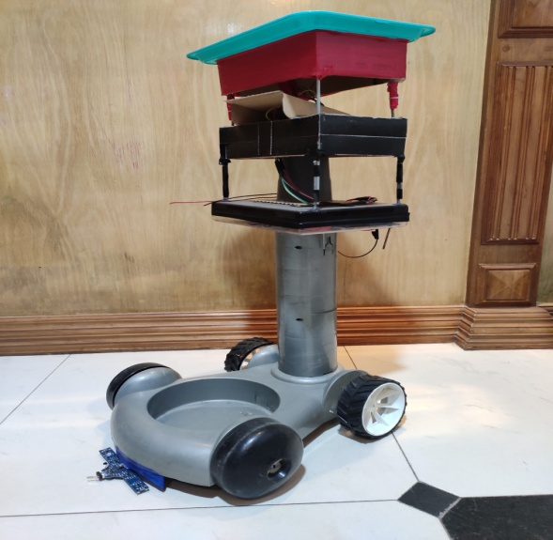
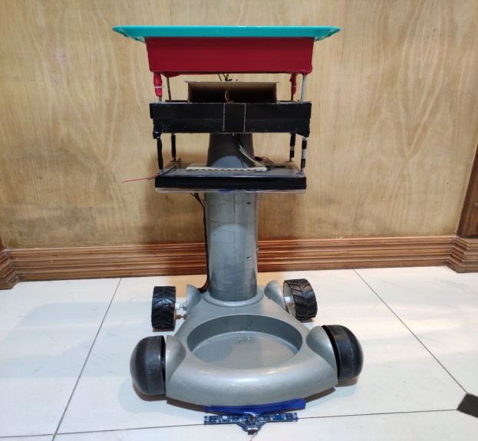

This is a transport device made by our Robodex team to give you an example of what we’d expect. We can feed the information (through programming) of where the destination is and the bot will automatically go there. This can be useful in hospitals as we can place medicines in the tray above the bot and it can automatically go to the room where the diseased person is. This will minimize the contact between the diseased and the healthy.

Note :
- All registrations should be sent to robodexclubdpsdwarka@gmail.com along with the name, class, contact number and email id of participants and the contact number and mail id of teacher in charge.

- Any Idea Related To The Given Example Will Not Be Acceptable

For further enquiries please contact:
Teacher I/c., Ms. Shikha Sethi : 9818807952
Teacher I/c., Ms. Pooja Batra : 9810164182
Parv Narang, President : 9910066759
Arnav Batra, Vice President : 9899859025
Saumil Goel, Tech Head : 8851465174
Shounak Dua, Secretary : 7982114055

